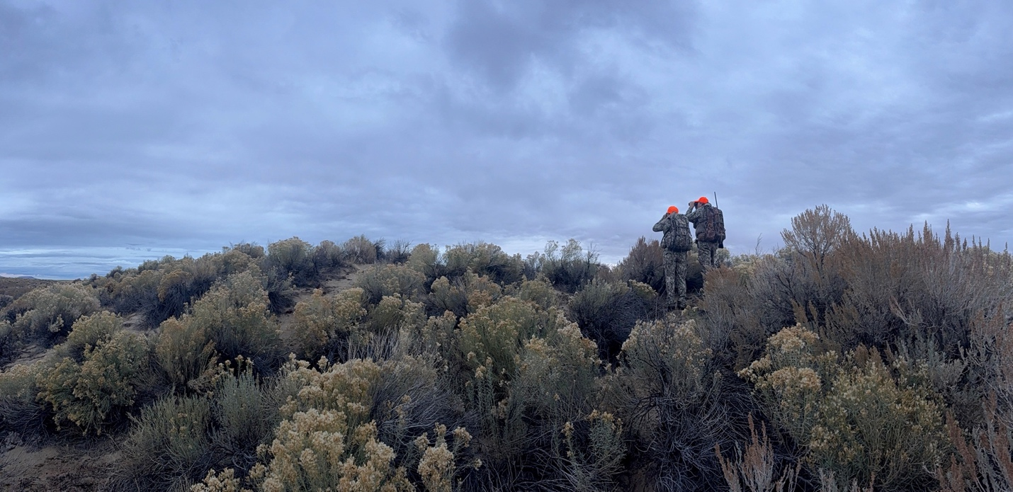

Tonya and Jason Atkins glassing for elk.

The Heart of the Hunt: Becoming Artemis

By Angelica M. Tirado-Cruz

Nov 2025

Hunting, Humanity, and Stewardship
I came to Wyoming for the first time in 1999. I had a one-year-old and was enrolled at Laramie County Community College. That first night it snowed, and being from South Carolina, I was thrilled to see the white fluffy stuff all over the place, especially since it was late June. It would be many years before I fully understood what it meant to be a Wyoming-ite.
Several degrees later, including an M.A. from the University of Wyoming, after children, a divorce, and multiple job changes, I finally found myself working for a trona mine just outside Green River, Wyoming. When I accepted the role of Communications Specialist, I was eventually invited to help with something called the Big Game Brag Board. The team wanted someone who could help with the internal marketing and communications side of it. I agreed, not realizing this invitation would become a pivotal moment in my life.
Hunting is often misunderstood. Those who see hunters as bloodthirsty have not seen a single mother receive a donated deer from a hunter who wanted to feed her five children. They have not seen the quiet generosity of men and women who harvest responsibly and donate the meat to local food banks so that others in their communities can eat.
Hunters are an important part of tending the resources of nature. They are a cornerstone of conservation in the United States, helping control herd populations and maintain ecological balance. Their efforts protect habitats and prevent overpopulation that can lead to starvation and disease. For every critic who dismisses hunting as cruelty, there is a family somewhere giving thanks over a meal that came from the land, not the store.

The Big Game Brag Board
The Big Game Brag Board (BGBB) was established in 2011 by a group of hunting enthusiasts here at the Big Island Mine. Back then, measuring horns was a detail-oriented and highly competitive affair. These days, it is less formal but just as spirited. The only official measurement now is how long the story is behind the hunt.
I joined the BGBB in 2023, and I had no idea how much the experience would affect me or what I would become because of it. When I was asked to help out, curiosity got the better of me.
My first outing was with old college friends Jason and Tonya Atkins, who are avid hunters. I remember walking through the backwoods of the LaBarge area in borrowed camo, mostly worried about running into a bear or mountain lion. I was fine seeing one from a distance, but this city girl was not ready for anything closer.
I did not hunt that first or even the second year. I was more of a glorified pack animal, there to help if something was harvested. But those trips taught me the art of silence and the value of “snoozers,” the quick naps you take while waiting for your hunting partner to spot something.
Once, I got spooked when I heard what I thought was a strange helicopter. To my surprise, it was only a bird in flight. The sound of its wings took me back to my childhood, reminding me how disconnected I had become from what truly matters. Out there, with zero signal and no screens, I reconnected with nature and with myself.
Sure, about ten percent of it involves a sharp knife, plastic gloves, and a bit of blood. But the other ninety percent is just a good hike in nature. Now, with my own camo and knife in hand, you may call me an Artemis in training.

The Heart of the Hunt
What I have learned is that hunting is not about bagging, tagging, or bragging. It is about stewardship and caring for the land and the wildlife that sustain us. Responsible, regulated hunting helps maintain balance among animal populations and prevents overuse or starvation. It is part of how we give back to nature, ensuring that future generations can experience the same wilderness we cherish today.
Hunting, at its core, is not about taking life. It is about preserving it through conservation, education, and acts of quiet generosity. It is a legacy of respect for the land, the animals, and the people who continue to learn from both.

A New Chapter
In October 2025, I went on my very first hunt. I thought I had all the paperwork in place but quickly realized I did not, my first rookie mistake. I was determined that my first experience would not fall under the umbrella of poaching. So as soon as I returned home, I made sure everything was in order and headed back out two weekends later.
Tonya and Jason had drawn tags in Area 100 near the Killpecker Sand Dunes. My first three shots were out there with them, but I had left my other bullets back in the Razor, my second rookie mistake. I did not yet understand how special that place was until they told me it was one of the best hunting areas in the region, home to large herds. Then it hit me: that was where the pictographs were.
I had visited the Killpecker Sand Dunes before, taken family and friends to see the pictographs, and even gone sledding there with a friend from Georgia who had never seen such a sight. Standing there again, rifle in hand, I thought about how ancient that land is. Native Americans had hunted there for centuries. Even though my Native ancestry comes from the Taíno people of the Caribbean, I could not help but feel a sense of unity with those who had once walked this same ground.
The romantic side of me whispered that I wanted to harvest a bull elk in this sacred place, a symbol to remind me of my family’s story, of our connection to the land, and of the generations before and after me.
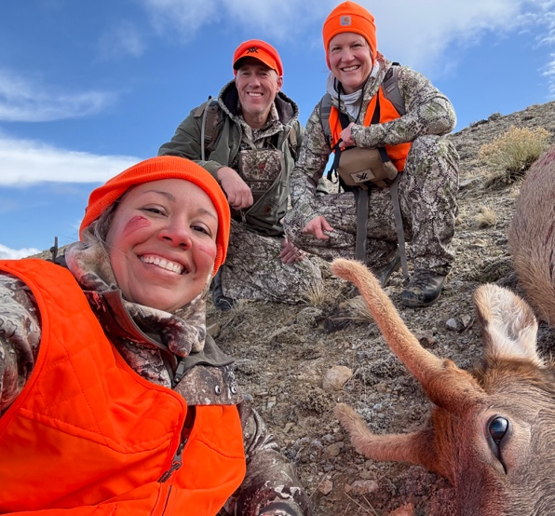
When we came across the first herd, I took my shots but ran out of ammunition before I could connect. Still, we did not give up. Later, crouched low and moving slowly in what I can only describe as a duck-walk, I followed Tonya’s quiet lead as we spotted a group of young spike bulls about 200 yards away. I took a deep breath, steadied my aim, and as I exhaled, squeezed the trigger.
Center mass.
It was a powerful, humbling moment. I was not sure how I would feel; I had never taken a life before. But as I stood there, I reminded myself that this was a more humane end than what many animals face in industrial settings. My shot was clean, and the elk did not go far. That mattered deeply to me.
I had never field dressed an animal before, but thanks to a YouTube video Tonya sent me, I knew where to begin. Knife in hand, I started the process with her guidance. It was both surreal and sacred. I named him Spike Lee, a small gesture of gratitude for the life that would now sustain others.
I took the meat to Henderson’s Meat Packing in Lyman, Wyoming, a wonderful family I have known for years. Driving home from Area 100 with that harvest in my car, I felt something ancient stir inside me. For the first time, I truly understood what it meant to provide, to feed my family, my friends, and even neighbors if they ever needed it.
It was a moment of power, humility, and connection all at once. It built a confidence I did not know I was missing. And as I look back on that experience, I know one thing for certain: I will forever be Artemis.

